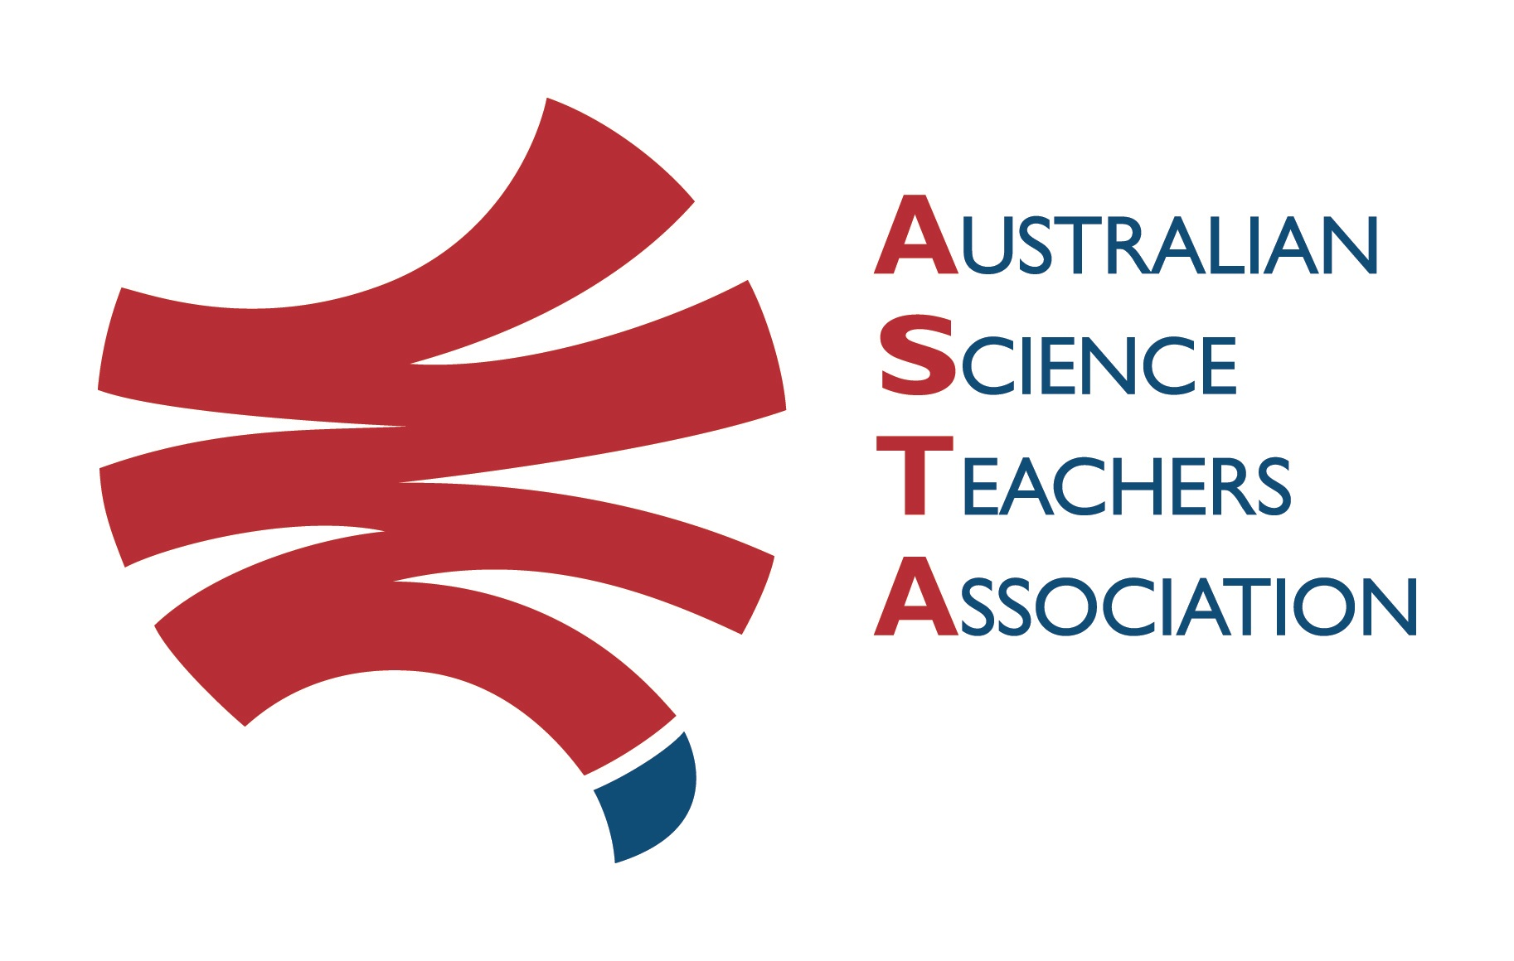
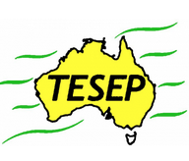

Professional Development Workshop Series in Earth and Environmental Science
TESEP PRESENTS: AFTER SCHOOL PROFESSIONAL DEVELOPMENT (PD)

Wed 13 March 2024 - for Science/Geography secondary teachers/lab-technicians & upper primary teachers - at 2:30pm - 4:30pm
PD workshop – re Vic curriculum VCSSU100, 115,116,122,127,089:
Rocks (& the TESEP Aust. Rock Kit teaching pack, explained) and the integrated Plate Tectonics story of Rocks (tour around the TESEP Plate Tectonics poster, land use/infrastructure/how we use the Earth/ water cycle) year 4 to 8 focus
- with classroom-ready Powerpoints, videos, hands-on exercises, weblinks

Venue: Quantum Victoria (grounds of Charles Latrobe College), 235 Kingsbury Dr, Macleod Vic
Meeting Room: go to front office to sign in & be directed to meeting room
Date: Wednesday 13 March 2024, PD workshop Facilitator: Sarah Gerardson

The Earth-Expo experience includes–
1. PD workshops – After-school professional development workshops for teachers (1-PD sessions @ $38 per attendee for registering teachers, page 2 to register).
3. ASTA Certificate of attendance – A certificate of hours and workshop outcomes will be issued.
4. PD topics are from TESEP’s “The Challenging Earth” series 2
5. Webinars - Also, see www.tesep.org.au events – for FREE WEBINARS (each 1 hour, 6-part series, run after-school each term)
Presenter: An experienced secondary Science teacher/earth scientist or an educator geologist, who has worked in industry, accompanied by a young earth science post-graduate presenter, with many rock/ Earth-Mineral stories and samples to share.
29 Palm-sized rocks in the TESEP Australian Rock Kit for Schools & close-up of TESEP Plate Tectonics poster, NEW - TESEP Aust. Mineral Kit for Schools (from Haines Educational)
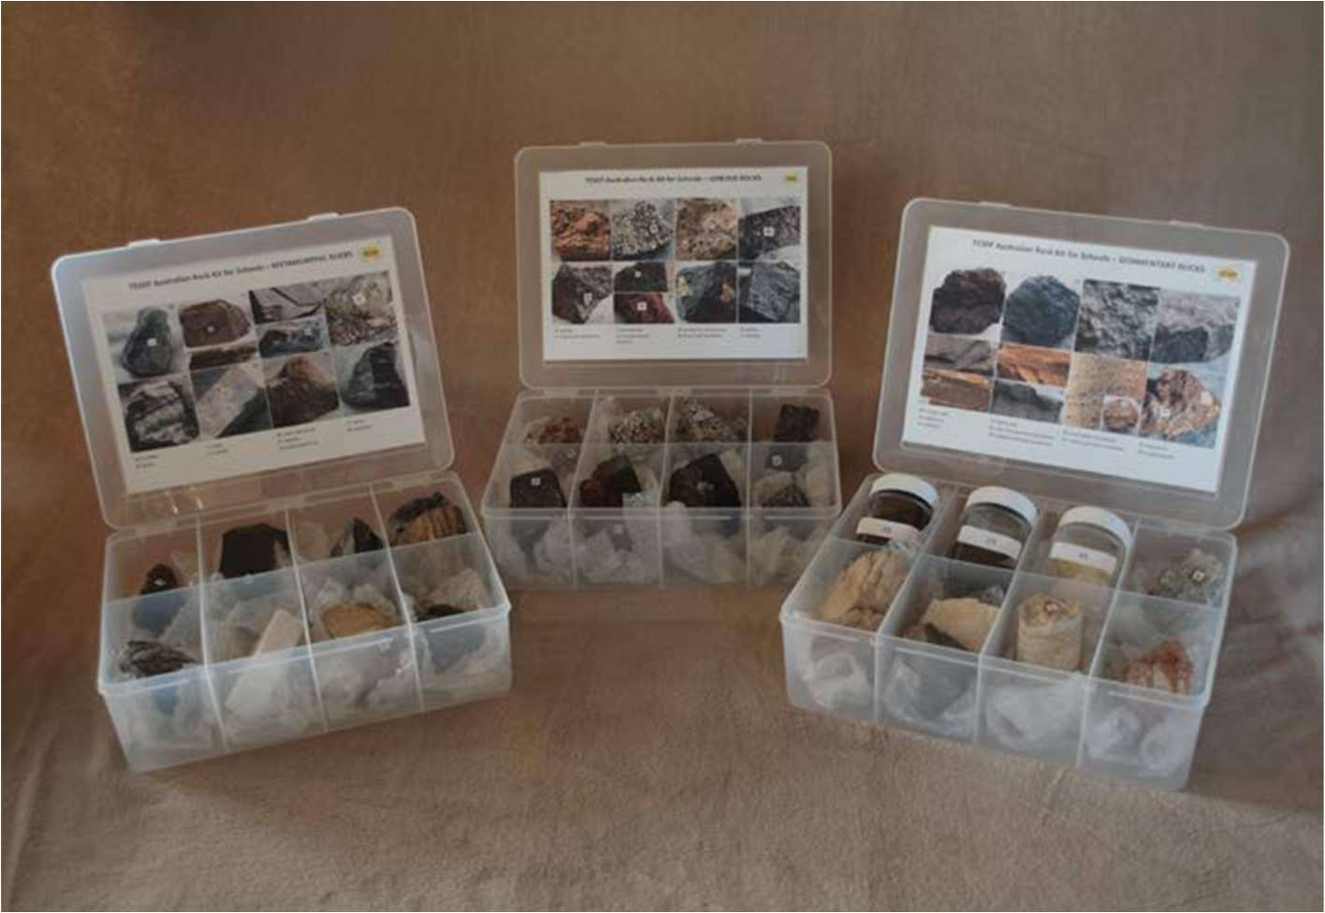
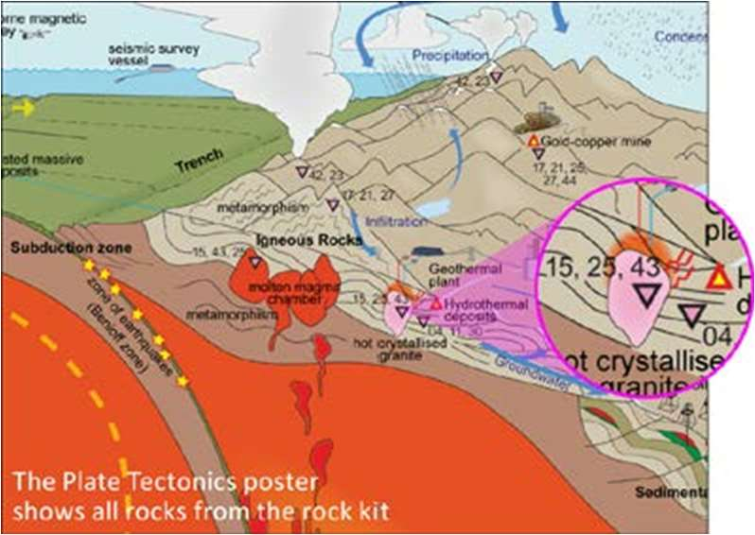
tesep.org.au

asta.edu.au
Booking form
Name:
School:
Teaching Area:
Phone (School):
Email:
Home postal address:
Special Dietary and other requirements:

Professional Development Workshop Series in Earth and Environmental Science
Email or fax form to ASTA (office manager – Michelle Lollback). Send the non-refundable* registration fee (includes GST) to Australian Science Teachers Association (ABN 87 902 882 824).
Payment can be made by direct bank transfer or cheque/money order. Please include your name and workshop details with payment (e.g. TESEP PD9 NSW July 20 J. Citizen).
*The fee is transferable to another PD workshop or for another teacher to substitute
Email registration to: officemanager@asta.edu.au | Address: TESEP - ASTA  PO Box 334 Deakin West ACT 2600
Account Details: Australian Science Teachers Association (ASTA) BSB: 082 902 Account No: 556 705 700

Please tick here if you require an invoice ☐ and provide address if different from the one above:

A certificate will be issued by ASTA which states the number of PD attendance hours. For registration inquiries contact officemanager@asta.edu.au
Please Note: Issuing of a certificate is conditional on workshop payment and in-filling of a short feedback questionnaire.

Registration fee: Free for teachers working at the host school and other sponsored schools. $38 per attendee (secondary Science/STEM/Geography teachers/lab-technicians/upper primary teachers)

please print clearly
Workshop: 1-PD Rocks & Plate Tectonics VCSSU102, 114, 127 & 089 | Date: Wed 13 March 2024
Venue: Quantum Victoria, 235 Kingsbury Drive, Macleod Vic 3085 | State: VIC

